Greggs plc: Using App Data to Bake Smarter
Mid-term note – The Strategy of Digital Transformation – 30 October 2026
Introduction
Greggs is a UK-based company that sells food, and it has around 2,700 branches (Greggs plc, 2026). Its profit went down by about 4% (Greggs plc, 2026), and the cost of hiring staff also went up (HM Treasury, 2024). The shops do not bake based on customer demand; they rely on their own guesses, which leads to leftover food. Using the information from everyday orders on the app, Greggs can predict what to bake in future, which will also help it plan how many staff it needs. I chose Greggs because I buy from it myself: there is a shop close to my university, and I find it reliable.
1. Value opportunities
Economic: People have less money, so they buy cheaper things. This means Greggs cannot simply raise its prices to cover higher staff costs (HM Treasury, 2024), because it would lose customers. Near my university, I could also buy cheap food at McDonald's or Subway. I still choose Greggs because it is reliable. This shows that customers can easily go somewhere else, so Greggs has to keep its prices low (Porter, 2008).
Social: When people order through the Greggs app, Greggs keeps more of the money. When they order through delivery apps like Uber Eats, part of the money goes to the app, so Greggs loses out (Greggs plc, 2026). Evening is also Greggs' fastest-growing time of day, at 9.4% of sales in 2025 (Greggs plc, 2026). Students studying late, like those at my university, and people finishing work or late shifts want cheap food in the evening. This means shops need to bake different food at night, such as pizza instead of breakfast items, which is hard to get right by guessing.
Environmental: Leftover food makes Greggs lose money, because that food could have been sold for a profit. Instead, it goes bad or is given away. Greggs already sells some leftover food cheaply at the end of the day through the Too Good To Go app, which has saved more than 5 million meals since 2021 (Grocery Gazette, 2025). This helps, but Greggs earns much less than it would by selling the food at full price. It would be better not to bake too much in the first place.
2. How the business model will change
Greggs gives customers cheap food in shops that are close by and reliable (value creation, C1 in Figure 2). However, each shop does not bake based on customer demand; it relies on its own guesses, which leads to leftover food (value configuration, C2). Greggs makes money by selling lots of cheap items to lots of people (value capture, C3) (Greggs plc, 2026).
When I searched for Greggs on Google on 30 October 2026, the "Order online" page offered delivery through Uber Eats, Just Eat and greggs.com, and Uber Eats showed a service fee of 5–15% (Figure 1). When I chose pickup, only Uber Eats and Just Eat appeared; Greggs' own app was not offered. This means that even customers who collect their food themselves may order through these apps, so part of the money goes to them and Greggs loses out.
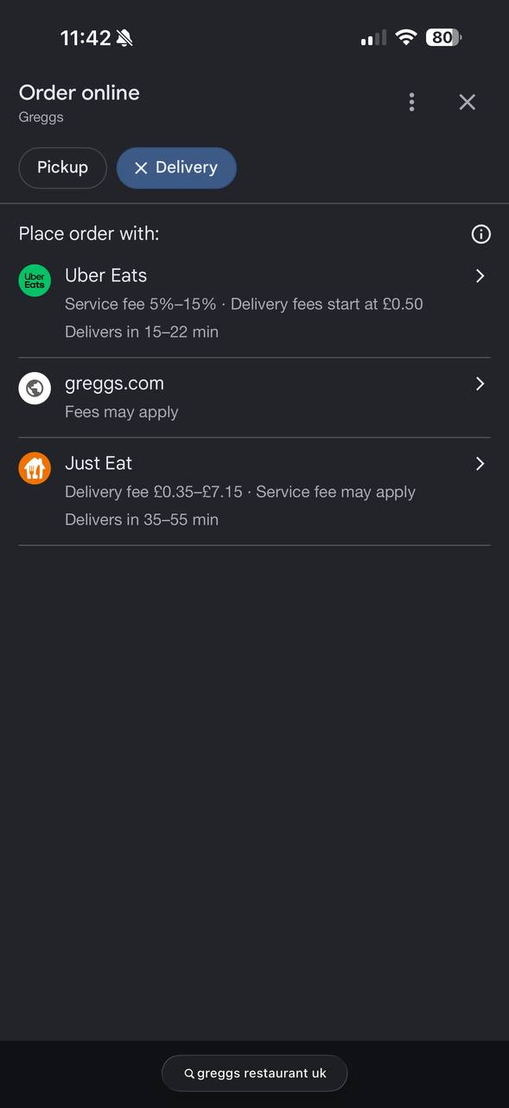 | 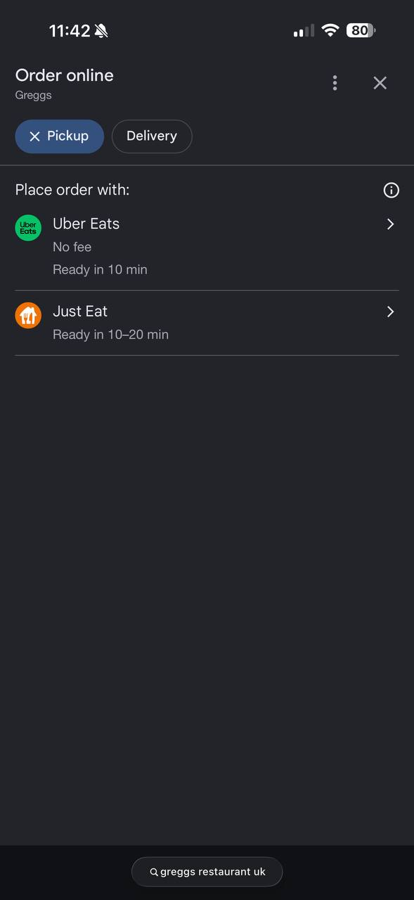
Figure 1: Google "Order online" options for Greggs, delivery (left) and pickup (right) (my own screenshots, 30 October 2026)
Using the information from everyday orders on the app, Greggs can predict what to bake (P2), which will also help it plan how many staff it needs. This means less leftover food, which could instead be sold for a profit.
With this plan, customers would find their favourite items sold out less often, and they could skip the queue by ordering ahead in the app (new value creation, P1). This matters to me: once at lunchtime, the item I wanted was sold out, so I left and went to Subway, and Greggs lost that sale. With the new plan, Greggs would throw away less food and would not pay Uber Eats a cut on orders made in its own app (new value capture, P3). This links value creation to value capture, as a strategy should (Collis, 2021). Figure 2 compares the current business model with the new one.
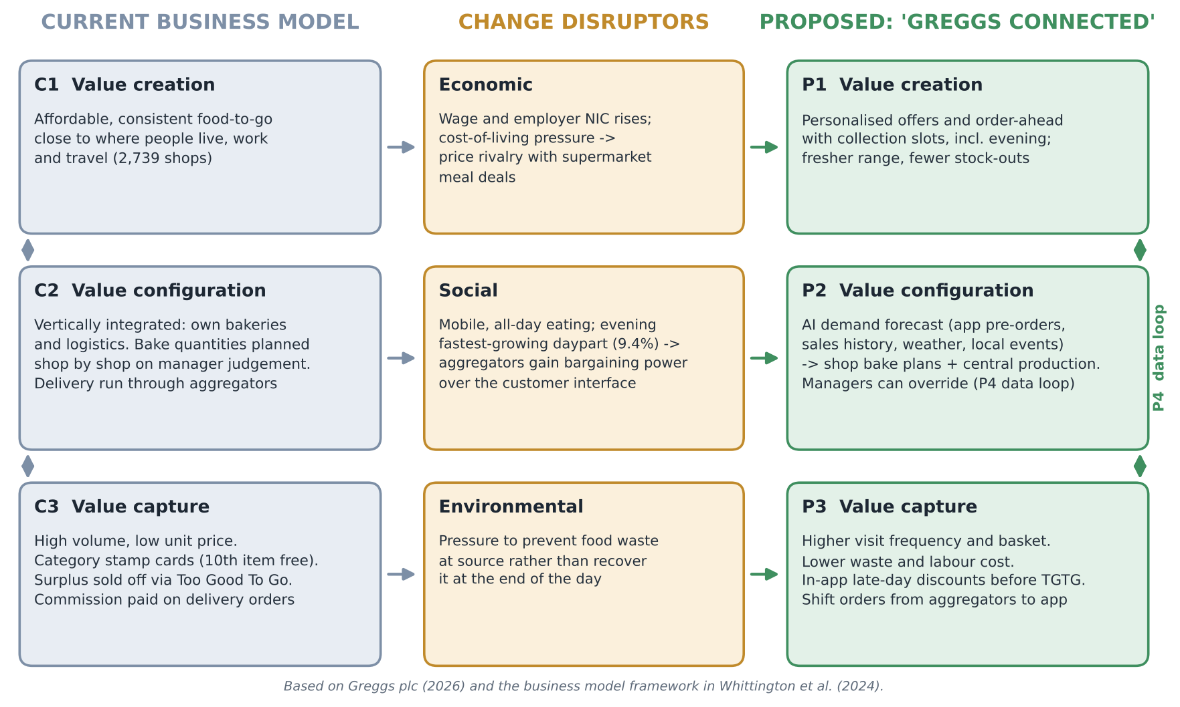
Figure 2: Current versus proposed Greggs business model
3. Competitive advantage
Greggs has a hybrid competitive advantage: it is cheaper than rivals such as Subway, but it also has something special, like its famous sausage roll (Whittington et al., 2024). My plan makes both sides stronger. Less food thrown away and not paying Uber Eats a cut save Greggs money, which helps it stay cheap. Fewer sold-out items and skipping the queue by ordering ahead make customers happier, which makes Greggs more special. Rivals such as Tesco could also build an app, so the app alone is not special. What they cannot easily copy is that Greggs has its own bakeries and lorries, so it can use app data to change what is baked and delivered to each shop (Porter, 1996).
4. Challenges
About 70% of digital transformations fail to meet their goals (McKinsey, 2025, cited in Curchod, 2026d), so these challenges matter.
Staff: shop managers who have always decided how much to bake may resist the new system. Some may be confused because nobody has trained them to use it, and others may be scared that a computer will replace them. The lecture calls this ground-level resistance, caused by a lack of understanding or by fear (Curchod, 2026a).
Leaders: Greggs' leaders may see the app as just a marketing tool for discounts, not as something that should change how the company bakes. The lecture calls this bounded rationality (Curchod, 2026a). Money is also tight: Greggs spent £287.5 million on investment in 2025 while its profit fell (Greggs plc, 2026), so leaders may prefer to wait.
Company habits: Greggs has had record sales doing things its own way, so people may ask why it should change. This is a competency trap, where the strengths that made a company successful stop it from changing, as happened to Nokia (Leonard-Barton, 1992).
5. Overcoming the challenges
Fixing staff resistance: Greggs should train shop managers to use the new system, so they are not confused. The computer should only suggest how much to bake, while the manager still makes the final decision, so staff are not scared of being replaced. This also covers a weakness in my own plan: the AI forecast may get unusual days wrong, such as a sudden storm or a football match, so shops could still run out of food. Because the manager makes the final decision, they can change the bake on those days.
Fixing the leaders' challenge: Greggs should set up a small separate team for this project, so the rest of the business keeps running normally. This is called ambidexterity (O'Reilly and Tushman, 2004). The team should first test the system in about 50 shops in one city. This costs little, and if it works, leaders will have proof before spending more. Building this habit of testing new ideas creates dynamic capabilities (Teece, 2007).
The agile model: Today, Greggs has a low level of agility, because every shop follows head-office rules. It should aim for a medium level, with agile working only for the app project (Curchod, 2026b). Processes and routines: the small test team tries the system in a few shops, learns from it and improves it. Skills and employee development: shop managers are trained, and Greggs hires data and AI experts. Communication and transparency: because most shop staff do not sit at a computer, Greggs shares the test results through a staff app on their phones, as IKEA did, and managers collect opinions in a short chat at the start of each shift.
National culture: the UK has its own digital ecosystem, and customers already use Uber Eats and Just Eat (Curchod, 2026c). Greggs should not stop working with them, because it would lose customers to rivals such as McDonald's or Subway. Instead, it should keep these partners but give people a reason, such as app-only deals and rewards, to order more through its own app.
Conclusion
Greggs should use the information from app orders to decide what each shop bakes. This would mean less food wasted, and Greggs would keep more of its money instead of paying part of it to Uber Eats. To make the change work, Greggs should test it first in a few shops, with staff trained and involved.
Word count: 1348 words (excluding headings, figures, captions and reference list)
Reference list
Collis, D. (2021) 'Why do so many strategies fail?', Harvard Business Review, 99(4). Available at: https://hbr.org/2021/07/why-do-so-many-strategies-fail (Accessed: 30 October 2026).
Curchod, C. (2026a) 'The challenges ahead: potential obstacles to transformation and how to overcome them' [Lecture slides], The Strategy of Digital Transformation. University of Edinburgh Business School. Available at: Learn (Accessed: 30 October 2026).
Curchod, C. (2026b) 'Organizing for digital transformation: the agile organization' [Lecture slides], The Strategy of Digital Transformation. University of Edinburgh Business School. Available at: Learn (Accessed: 30 October 2026).
Curchod, C. (2026c) 'Beware national cultures: an exploration of the East vs. West digital ecosystems' [Lecture slides], The Strategy of Digital Transformation. University of Edinburgh Business School. Available at: Learn (Accessed: 30 October 2026).
Curchod, C. (2026d) 'Strategy starts with value opportunities: macro, industry and firm-level analysis in the digital age' [Lecture slides], The Strategy of Digital Transformation. University of Edinburgh Business School. Available at: Learn (Accessed: 30 October 2026).
Greggs plc (2026) Preliminary results for the 52 weeks ended 27 December 2025. Newcastle upon Tyne: Greggs plc. Available at: https://assets.greggs.com/f/162306/x/e616871d6c/260303-greggs-2025-preliminary-results-final.pdf (Accessed: 30 October 2026).
Grocery Gazette (2025) 'Greggs saves 5m meals from waste with Too Good To Go', 30 April. Available at: https://www.grocerygazette.co.uk/2025/04/30/greggs-too-good-to-go/ (Accessed: 30 October 2026).
HM Treasury (2024) Autumn Budget 2024 (HC 295). London: HM Treasury. Available at: https://www.gov.uk/government/publications/autumn-budget-2024 (Accessed: 30 October 2026).
Leonard-Barton, D. (1992) 'Core capabilities and core rigidities: a paradox in managing new product development', Strategic Management Journal, 13(S1), pp. 111–125. doi: 10.1002/smj.4250131009.
O'Reilly, C.A. and Tushman, M.L. (2004) 'The ambidextrous organization', Harvard Business Review, 82(4), pp. 74–81.
Porter, M.E. (1996) 'What is strategy?', Harvard Business Review, 74(6), pp. 61–78.
Porter, M.E. (2008) 'The five competitive forces that shape strategy', Harvard Business Review, 86(1), pp. 78–93.
Teece, D.J. (2007) 'Explicating dynamic capabilities: the nature and microfoundations of (sustainable) enterprise performance', Strategic Management Journal, 28(13), pp. 1319–1350. doi: 10.1002/smj.640.
Whittington, R., Regnér, P., Angwin, D., Johnson, G. and Scholes, K. (2024) Fundamentals of strategy. 6th edn. Harlow: Pearson.

